Lab #2 – Metals Analysis –DUE 10/20/2015

Please submit a paper or electronic copy to the TA (Yinsui_zheng@brown.edu).

**I. Background [20 pts]**

Mass spectrometry is a powerful analytical tool that allows us to quantify individual molecules with a high degree of accuracy. This section will focus on some of the fundamental concepts of mass spectrometry. Visit the class website (<http://zhengyinsui.github.io/metals.html>) and navigate to the interactive mass spectrometer app located at the bottom of the ‘Metals Lab’ page. You’ll see something like the diagram below.

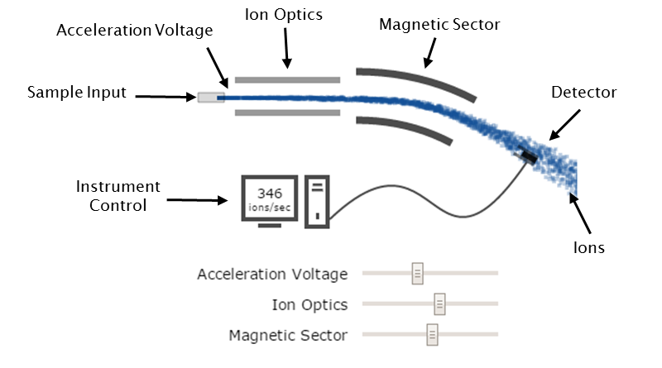

**Figure 1. Basic components of a mass spectrometer.**

Mass spectrometers manipulate the path of a molecular ion through a series of steps. Adjust the three sliders labeled: ‘Acceleration Voltage’, ‘Ion Optics’, and ‘Magnetic Sector’ and observe how the ion trajectory changes. Briefly describe the role of the following mass spectrometer components (i.e. how does each affect ion movement):

1. Acceleration Voltage:

1. Ion Optics:
2. Magnetic Sector:

**II. Data Processing [40 pts]** *follow instructions and provide excel file to receive credit

Samples from the Pawtuxet river and Hundred Acre Cove dataset (20 samples) were analyzed by ICP-MS for 23 different metal species. Processing this dataset generates 460 unique data points (or 600 including the calibration data). Obtain a copy of the raw dataset (*2015_Geo1370_Metals results.xlsx*) from the class website (<http://zhengyinsui.github.io/index.html> or <http://zhengyinsui.github.io/metals.html>).

**II(a). Calibration Data**

First generate calibration curves for each of the 23 metals. The calibration dataset is located under the ‘Calibration’ tab. Establish a linear regression (y = mx + b) equation for each element using the built-in Excel functions.

* Calculate slope (m) by entering the following equation:

=slope(B3:E3, B2:E2)

* This will calculate slope for the first row only. Before applying this equation to all rows, modify the equation to keep the reference to cells ‘B2:E2’ constant:

=slope(B3:E3, B$2:E$2)

* Calculate intercept (b) in the next column:

=intercept(B3:E3, B$2:E$2)

* Calculate correlation coefficient (R2) in a third column:

=correl(B3:E3, B$2:E$2)

Before applying these calibration curves to the sample dataset, verify the correlation coefficient for each regression is high enough to proceed.

* In a new column, use the ‘if’ function to see if the correlation coefficient is **below** 0.95. Enter the following equation and apply it to all rows:

=if(H3<0.95,”Warning”, “”)

The ‘if’ function will compare the value in the designated cell with the criteria provided (e.g. designated cell: H3, criteria: <0.95). When the comparison is ‘true’, we tell it to output the word “Warning”. If the comparison is ‘false’ it will output nothing (“”).

* The correlation coefficient of all the elements should high enough. No ‘Warning’ should be found in the table.

**II(b). Sample Data**

By applying functions to our data, we can process large amounts of data in seconds. Go to the “Sample” tab in the excel data file. Each row consists of the element name, sample name, and the elemental abundance measured by the ICP-MS. If you scroll down to the end of the dataset you will see there are 460 measurements to process.

To convert these abundance values to concentration values, we need to apply the correct calibration curves to each row of data. Let’s start by matching the elements in each row to their corresponding slope and intercept values in the “Calibration” tab.

* Use the ‘vlookup’ function to lookup a desired value and return another value from the same row, different column. Here’s a graphical depiction of ‘vlookup’:

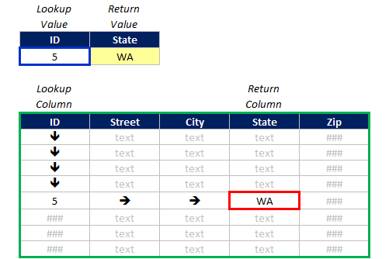

* To apply this function to our data, in a new column in the “Samples” tab, use the following equation to obtain the matching ‘slope’ values from the calibration table:

=vlookup(A2, Calibration!$A$3:$G$25, 6, 0)

This function will take the input value (A2) and find its location within another data table (Calibration!$A$3:$G$25). The “$” symbols make sure the function always looks in the same place. The number ‘6’ tells the function which column to return (in this case the ‘slope’ value). The last value ‘0’ tells the function there must be an exact match for the lookup value.

* In a new column, retrieve the matching ‘intercept’ values:

=vlookup(A2, Calibration!$A$3:$G$25, 7, 0)

Apply these equations to all rows in the “Samples” tab.

* Convert the abundance to concentration for all 460 measurements. Our x-values are concentration and y-values are abundance:

=(C2-F2)/E2

* Lastly convert any negative values to 0. In a new column enter the following equation and apply it to all rows:

=if(D2<0, null, D2)

This last equation will return ‘0’ when the concentration value is negative. Otherwise it will return the concentration value with no change.

*Save the Excel sheet you used to perform the above steps. When saving, include your initials in the file name. Email a copy to [Yinsui_zheng@brown.edu](mailto:Yinsui_zheng@brown.edu) when you turn in everything else.

**III. Data Analysis [40 pts]**

Explore the **final elements concentration dataset you got** from on Part II analysis or the database on **website (**[**http://zhengyinsui.github.io/data.html**](http://zhengyinsui.github.io/data.html)). There are two dropdown menus above the scatter plot that allow you to compare any two variables. Hovering your mouse over any data point will highlight its location on both the map and scatter plot. Points are colored by latitude.

Find one trend in the metals dataset and answer the questions below. One variable must be from the metal dataset (e.g. Li, Se, Mo, etc.). The other variable may be anything (e.g. another metal, latitude, longitude, pH, dissolve oxygen3 etc.)

[**5** **pts**] What trend did you find?

* Variable A:
* Variable B:
* Positive/Negative/Non-Linear:

[**20 pts**] What could cause the correlation between these two variables? Try to apply what you know about the environment to come up with a plausible reason for this correlation.

[**7 pts**] Backup your claim. Provide one source that supports your answer above (e.g. journal article, wikipedia entry, quote from a textbook, etc.).

[**8 pts**] What is the general metal concentration difference between water samples from Pawtuxet River and Hundred Acre Cove?